The Youth Formula: Tips to Feel Young

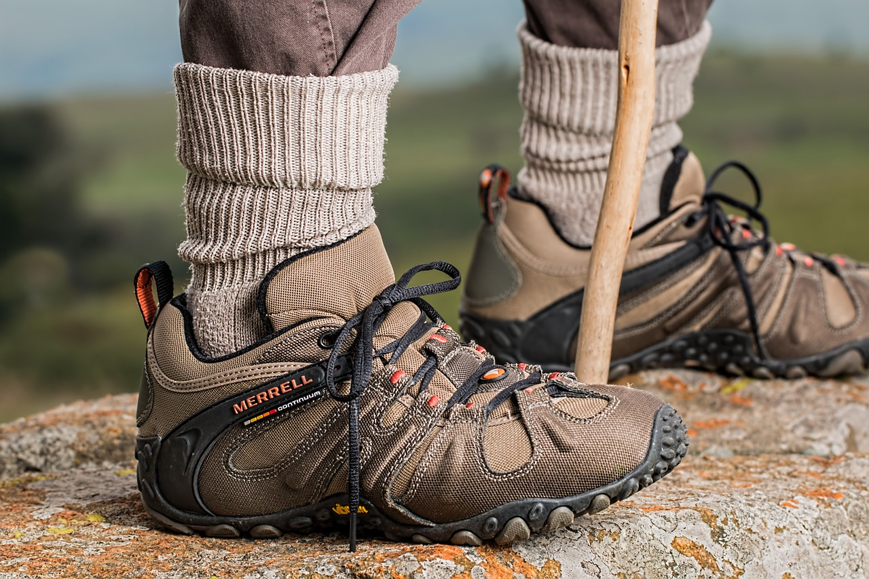

Photo via Pixabay by [Steve Buissinne](https://pixabay.com/en/shoes-rock-climbing-hiking-walking-587648/)

The stigma that fashion icons have no brains cannot be applied to [Coco Chanel](https://www.phactual.com/13-quotes-about-growing-old-and-staying-young/), at least when it comes to aging. “Nature gives you the face you have at twenty; it is up to you to merit the face you have at fifty.” Getting older isn’t a choice, but slowing down the process is. Here are some tips to keep you feeling young:

**EATING HEALTHY**

Rummage through your storage bins for those bell-bottom jeans from high school. Eating well may save you time on shopping for new pants by maintaining a healthy body weight. But everyone knows the outer physical affects of eating a balanced diet. What you may not know is that [good nutrition](http://www.helpguide.org/articles/healthy-eating/eating-well-as-you-age.htm) boosts immunity, improves mental acuteness by improving focus and decreasing the risk of Alzheimer’s disease, raises your energy level, and increases your mood and self-esteem. Everything is connected – when your body feels good, your mental state will follow.

* **Create a Healthy Diet:** Our bodies were not made to crave processed foods. The key to healthy eating is to find food that is as close to its natural form as possible.
* **Get Enough Calcium:** Consuming at least 1,200 mg of calcium a day can prevent osteoporosis and bone fractures. Sources of calcium include milk, yogurt, and cheese, and if you’re looking for a non-dairy option, eat some tofu, broccoli, almonds, and kale. And while we’re at it, eating whole-milk dairy products leads to less body fat and lower levels of obesity.
* **Cut Down on Sugar and Refined Carbs:** Slowly reduce the sugar in your diet a little at a time to give your taste buds time to adjust to the change. Increase sweetness of meals with naturally sweet foods like color-rich fruits, peppers, or yams. Stick with complex carbs like oatmeal and beans that are high in fiber instead of refined carbs. Don’t replace fat with carbs. Remember, low-fat versions of your favorite foods are often packed with sugar and artificial sweeteners to make up for the taste.
* **Prevent Malnutrition:** Malnutrition causes fatigue, depression, a weak immune system, anemia, and digestive, lung, and heart problems. Be sure to eat [nutrient-packed foods](https://authoritynutrition.com/11-most-nutrient-dense-foods-on-the-planet/) like salmon, garlic, and potatoes, and have flavorful snacks between meals. Eating is a production, and if done right, there is some planning involved. Food preparation is key, so seek help if needed. It can also be a social event, so avoid eating alone. Ask some friends or family members to dine with you.

**STAYING ACTIVE**

One of the [myths](http://www.helpguide.org/articles/exercise-fitness/exercise-and-fitness-as-you-age.htm) that older people shouldn’t exercise can be put to rest. Research shows that for people over 50, a sedentary lifestyle may result in more trips to the doctor, medicines for illnesses, and even hospitalizations. Exercising regularly can slow the decline in strength and vitality, and in some cases, improve it.

* **Enjoy It:** When you dread exercising, it can be difficult to find the motivation to hit the gym. It is just as, if not more, important to find activities that you like and do to it [regularly](http://orthoinfo.aaos.org/topic.cfm?topic=a00103). Listen to music or take pictures as you hike, join a group fitness class to make new friends, or play fetch with your dog. Staying active doesn’t have to be difficult, it can be fun.
* **Be Active Outside of Workouts:** Choose stairs over the escalator, park on the outskirts of the parking lot at the convenience store, tend a garden, or use a set of free weights to lift while catching up on the news.
* **Stretch:** Take 10 minutes out of your day to [increase flexibility](http://www.everydayhealth.com/longevity/staying-active.aspx) and allow easier movement.
* **Don’t Fear Pain:** Just starting out, you may experience some soreness, but if you make it a routine then with time it will disappear. It doesn’t have to hurt! Switch to a different activity if you experience pain and swelling.

**SLEEP**

Not only does [sleep](http://www.sleepeducation.org/news/2013/08/07/sleep-and-growing-older) itself cycle, but the way we get sleep cycles. As you age, you often get less sleep than you need. It becomes harder to fall asleep, you wake up more often throughout the night, and you sleep less deeply, all of which affect your well being during the day.

* **Stick to a Schedule:** Go to sleep and get up at the [same time](http://www.webmd.com/sleep-disorders/guide/aging-affects-sleep#1) each day, even on weekends.
* **Take a Warm Bath:** The drop in body temperature afterward can help you relax and slow down.
* **Make the Bedroom a Sleep Zone:** Avoid watching TV, browsing through your [smartphone](http://www.helpguide.org/articles/sleep/how-to-sleep-well-as-you-age.htm), or even reading in your bed. Train yourself to think of your bed as a place for sleeping only.
* **Don’t Drink Alcohol Close to Bedtime:** Even small amounts can cause you to wake up in the middle of the night after the effects have worn off. And drinking less fluids period will cut down on trips to the bathroom.

Feeling younger is possible. It just requires discipline to change or maintain eating habits, daily activity, and sleep.